REPORT ON A SURVEY OF
RING OUZEL Turdus torquatus torquatus
TERRITORIES IN ROSEDALE AND OTHER AREAS
OF THE NORTH YORK MOORS IN 2008

Kendrick S. Hutchinson
Victor Fairbrother

January 2009

CONTENTS

1. INTRODUCTION 3
2. METHODOLOGY 4
3. RESULTS 5
Territories 5
Rosedale Area 5
Other Areas of the North York Moors 6
Nest Sites 6
Annual Breeding Results 6
First-Egg, Hatching & Fledging Dates 7
Productivity 8
Other 8
4. DISCUSSION 9
Weather Conditions 9
First Arrivals 9
Territories 9
Passage Migrants 11
Rosedale Nests 11
Hob Crag 11
Dalehead north 12
Round Hill south 12
Reeking Gill 12
Sheriff’s Pit 12
Sturdy Bank 12
Late Summer & Early Autumn Activity 13
Unattached Males 13
Sound Recordings, Sonograms and their Analysis 14
5. ACKNOWLEDGEMENTS 16
6. REFERENCES 16

ANNEX 1 - Nest sites and territories located in 2008 17
ANNEX 2 - Annual Breeding Results 18
ANNEX 3 - Table showing Aspect & Elevation of Nest Sites 19
ANNEX 4 - Nest Aspect & Elevation of Rosedale Nests 20
ANNEX 5/1 - Fine-Scale Habitat Survey of Nesting Area 21
ANNEX 5/2 - Fine-Scale Habitat Survey of Nest Site 22
ANNEX 6/1 - Daily Maximum & Minimum Temperature 23
ANNEX 6/2 - Daily Rainfall 24
ANNEX 7 - Sonograms 25
ANNEX 8 - Photographs of Hatchling Development 26

Front cover photograph: Ring Ouzel hatchlings at Sturdy Bank, June 2008.

1. INTRODUCTION

The 2008 survey was the ninth year in which a detailed study had been made of the ring ouzel Turdus torquatus torquatus (RZ) population in the North York Moors National Park and continued the work started in 1999 (foot & mouth preventing work in 2001). The findings of these studies were submitted to various bodies including the North York Moors National Park Authority, the RSPB Ring Ouzel Study Group, Natural England (York office) and the land owner and head keeper of Spaunton Estate.

As in previous years the 2008 survey concentrated on the Rosedale area of the North York Moors; an area of around 25 sq/km. For 2008 the help of a Rosedale resident provided a much needed pair of eyes (and ears) along the east side of the dale and gave considerable support to both Vic Fairbrother, covering the top-end of the dale north of Blakey Crossing, and Ken Hutchinson covering the central and southern part on the west side of the dale. Over 100 visits were made between March and October which amounted to some 500 hours of field work.

The 2008 season proved to be the best to date in that a total of nine nests were located in the Rosedale area; including one in North Dale, an adjoining dale leading off the main dale of Rosedale that was last surveyed in 1999. Following on last year’s success in locating RZs prior to migration, several visits were made during September and October to the main areas of rowan trees at the north-end of the dale.

Tables showing Annual Breeding Results and First-egg, Hatching & Fledging dates between 2000 and 2008 have been included for the first time.

A value for productivity for the 2008 breeding season has also been included - made possible by the large number of nests located this season.

For reference the results of the habitat vegetation surveys carried out between 2002 and 2007 have been included (Annex 5). These also show the results of Ian Burfield’s studies at Glen Esk and the Moorfoot Hills (Burfield, I. J. 2002 Table 5.6 pg. 88) for comparison.

As for the last two reports, graphs of temperature and rainfall for the months of March through to August have been included (Annex 6). The data was obtained from the weather station at Scaling Dam sailing club. Scaling Dam lies 15 kilometres northeast of Rosedale at an altitude of 190 metres.

A unique opportunity presented itself at Sturdy Bank to photograph the development of hatchlings at two day intervals between hatching and fledging. These are appended (Annex 8) and are useful in enabling a more accurate calculation of first-egg date from nests that are located at the hatchling stage.

Finally, a start was made on creating a database of sonograms (a graphic illustration of sound) of singing male ring ouzels. The aim being to use the male’s simple song as an ‘audiotag’ to identify and track individual bird’s movements without the need for ringing. Just as the patterns of each person's fingerprints are uniquely their own, the sonogram provides a way to determine a so-called voiceprint or "acoustic fingerprint". The purchase of specialist recording equipment was made possible by a generous grant from the North York Moors National Park Authority.

2. METHODOLOGY

As in previous years the core period of observation was from late March to mid July. Further visits were made in September and early October to locate ring ouzels prior to migration.

A territory was confirmed when: the male was observed singing at the same place on more than one occasion; when seen defending a territory; when nest building was observed; or when food was seen being carried to the nest.

The sampling protocol used in the fine-scale habitat survey was based on the Burfield method (Burfield, I. J. 2002). Eight equally spaced transects radiating out from the nest site for a distance of 200 metres were sampled at 25 metre intervals. At each of the 64 sampling points the percentage cover of various vegetation types lying within a 1^{m2} quadrat were recorded to the nearest 5% by eye.

Productivity measured as the number of young fledged per female per year was calculated from the equation: (mean brood size in successful nests) x (nest survival rate) x (number of breeding attempts per female). Nest survival rate was determined by the Mayfield method for the 9 nests located in 2008 using a nesting period (laying, incubation, nestling) of 29 days.

Audio recordings were made in digital .wav format and viewed on a PC using a specialist software programme that enabled the fine detail of each bird’s song to be displayed as a sonogram. The resulting analysis of key signature features - pitch and duration of note - provided each male with a unique ‘audiotag’ identity. These were then displayed as a bubble chart.

3. RESULTS

Territories

Rosedale Area

Table 1: Breeding ring ouzel territories occupied in the Rosedale area between 1999 and 2008.
(See map at Annex 1 for location of 2008 territories and nests.)

No. | Location  (all territories recorded to date) | Grid Ref. | Year
No. | Location  (all territories recorded to date) | Grid Ref. | 99 | 00 | 02 | 03 | 04 | 05 | 06 | 07 | 08
1. | Spaunton Moor - Spindle Thorn | SE 7160 9304 | ? | ✗ | ✓ | ✗ | ✗ | û | ✗ | ✗ | ✓
2. | Spaunton Moor - Loskey Ridge 1 | SE 7149 9345 | ? | ✓ | ✓ | ✓ | ✗ | û | ✓ | ✗ | ✗
3. | Spaunton Moor - Loskey Ridge 2 | SE 7132 9315 | ? | û | û | ü | ü | ✓ | ✗ | ✗ | ✗
4. | Rosedale west - Bank Top | SE 7200 9513 | ü | ü | ü | ü | û | û | ✓ | ✗ | ✗
5. | Rosedale west - Bank Top (east) | SE 7251 9454 | ? | û | û | ü | û | ✓ | ✗ | ✗ | ✗
6. | Rosedale west - Hob Crag | SE 7144 9538 | ? | ü | ü | ü | ü | ✓ | ✓ | ✓ | ✓
7. | Rosedale west - Thorgill Bank | SE 7072 9581 | ? | û | û | ü | û | û | ✓ | ✗ | ✗
8. | Rosedale west - Thorgill Head | SE 6999 9559 | ? | û | ü | ü | ü | ✓ | ✗ | ✗ | ✗
9. | Rosedale west - Sheriff’s Pit | SE 6965 9631 | ü | ü | ü | û | ü | ✓ | ✓ | ✗ | ✓
10. | Rosedale west - Sheriff’s Pit (south) | SE 6979 9610 | û | û | û | û | û | û | ✓ | ✗ | ✗
11. | Rosedale west - Round Hill (south) | SE 6940 9683 | ? | û | ü | ü | ü | ✓ | ✓ | ✓ | ✓
12. | Rosedale west - Round Hill (central) | SE 6927 9710 | ? | û | ü | ü | ü | û | ✗ | ✓ | ✓
13. | Rosedale west - Round Hill (north) | SE 6928 9740 | ? | û | ü | û | û | û | ✗ | ✓ | ✗
14. | Rosedale west - Sledge Shoe Bents | SE 6915 9776 | ? | ü | ü | ü | ü | ✓ | ✓ | ✗ | ✗
15. | Rosedale west - Matty Carr Hill | SE 6880 9833 | ? | û | û | ü | ü | ✓ | ✓ | ✓ | ✓
16. | Rosedale west - Matty Carr Hill (south) | SE 6896 9798 | ? | û | û | û | û | ✓ | ✗ | ✓ | ✗
17. | Rosedale west - Lion Inn | SE 6810 9987 | û | ü | ü | ü | û | ✓ | ✗ | ✓ | ✗
18. | Rosedale west - Blakey Swang | SE 6848 9981 | ? | ? | ? | ? | ? | ? | ? | ? | ✓
19. | Rosedale west - Dalehead (north) | NZ 6800 0092 | ü | û | ü | û | ü | û | ✗ | ✗ | ✓
20. | Rosedale west - Dalehead (west) | NZ 6821 0061 | û | û | ü | ü | ü | ✓ | ✓ | ✓ | ✗
21. | Rosedale east - Dalehead (east) | NZ 6870 0060 | û | û | û | ü | ü | û | ✗ | ✗ | ✗
22. | Rosedale west - Dalehead South | NZ 6821 0052 | û | û | ü | û | û | û | ✗ | ✗ | ✗
23. | Rosedale east - Reeking Gill | NZ 6919 0065 | ü | ü | ü | û | û | ✓ | ✓ | ✓ | ✓
24. | Rosedale east - Reeking Gill (west) | NZ 6892 0066 | û | û | û | û | û | û | ✗ | ✓ | ✓
25. | Rosedale east - Nab Scar | NZ 6950 0020 | û | ü | û | ü | ü | ✓ | ✓ | ✓ | ✗
26. | Rosedale east - Sturdy Bank | SE 6995 9989 | ü | ü | ü | ü | û | û | ✗ | ✗ | ✓
27. | Rosedale east - East Mine | SE 7055 9895 | ? | ? | ? | ? | ? | ? | ? | ? | ✓
TOTAL |  |  | 5¹ | 9 | 16 | 16 | 12 | 13 | 12 | 11 | 12
Note:
^{1.} Only a partial survey was carried out in 1999.

ü = occupied by pair û = not occupied ? = not checked

Other Areas of the North York Moors

Table 2: Ring ouzel sightings recorded in areas of the North York Moors other than Rosedale in 2008.

No. | Location | Grid Ref. | Comment
1. | Bransdale east - Ousegill Bridge | SE 638 947 | Territory recorded in 99/00/02/03/04/05/06/07
2. | Scalby Lodge¹ | TA 025 915 | 1 seen on 18/4.
3. | Ravenscar¹ | NZ 985 015 | 2 seen on 1/4 & 2 seen on 24/4.
4. | North Dale - North Gill | SE 725 998 | Territory recorded in 99.
5. | North Dale - West Gill | SE 718 996 | Territory recorded in 99.
6. | Kepwick Moor | SE 484 922 | 1 male seen on 19/5.
Note:
^{1.} Likely to be Fenno-Scandia passage migrants.

Nest Sites

Table 3: Ring ouzel nest sites located in Rosedale and other areas of the North York Moors in 2008.

No. | Location | Grid Ref. | Comment
1. | Rosedale west - Hobb Crag 1 | SE 7144 9539 | Located 04/05; predated at pulli stage.
2. | Rosedale west - Hobb Crag 2 | SE 7139 9545 | Located 29/05; predated at egg stage.
3. | Rosedale west - Sheriff’s Pit | SE 6971 9626 | Located 29/05; 4 pulli; all fledged.
4. | Rosedale west - Round Hill south | SE 6981 9664 | Located 04/05; 4 eggs; all fledged.
5. | Rosedale west - Dalehead north | NZ 6795 0102 | Located 05/06; 4 eggs; 1 hatched; predated.
6. | Rosedale east - Reeking Gill | NZ 6914 0056 | Located 12/05; 5 eggs; all fledged.
7. | Rosedale east - Sturdy Bank 1 | SE 6989 9991 | Located 05/05; 4 eggs; all fledged.
8. | Rosedale east - Sturdy Bank 2 | SE 6986 9990 | Located 16/06; 4 eggs; 3 fledged.
9. | North Dale - West Gill | SE 7179 9957 | Located 22/05; 3 pulli; 3 fledged.
10. | Bransdale east - Ousegill Bridge | SE 6385 9475 | 4 pulli ringed 24/5.

Annual Breeding Results

Table 4: Summary of annual breeding results at ring ouzel nest sites in Rosedale & other areas of the
North York Moors. Data from 2000 to 2008.

Year | Occupied Territories | Laying pairs  (2nd clutch) | Pairs that hatched young  (2nd attempt)  [2nd brood] | Pairs that had successful nests  (2nd broods/ attempts) | Pairs that failed completely | Total young fledged | Average brood size | Average  fledged young per laying pair
00 | 9 | 1 | 1 | 1 | 0 | 4 | 4.00 | 4.00
02 | 16 | 1 (1) | 1 (1) | 1 (1) | 0 | 4 | 4.00 | 4.00
03 | 16 | 6 (1) | 5 [1] | 3 | 3 | 11 | 3.66 | 1.83
04 | 12 | 4 (1) | 4 (1) | 2 (1) | 1 | 8 | 4.00 | 2.00
05 | 13 | 4 (2) | 4 (1) | 4 (2)ª | 0 | 13 | 3.25 | 3.25
06 | 14^{c} | 4 (1) | 3 (1) | 3 (1)^{b} | 0 | 10 | 3.33 | 2.50
07 | 12^{d} | 5 | 4 | 4 | 1 | 15 | 3.75 | 3.00
08 | 14e | 9(1) | 8^{f} (1) [1] | 6(1) | 3 | 23 | 3.83 | 2.55
Overall Average |  |  |  |  |  |  | 3.73^{g} | 2.89
Note
^{a.} One pair had two unsuccessful attempts before being successful at third attempt.
^{b.} One pair had one unsuccessful attempt before being successful at second attempt.
^{c.} Includes two territories in Bransdale.
^{d.} Includes one territory in Bransdale.
^{e.} Includes two territories in North Dale.
^{f.} One pair had two unsuccessful attempts; the 1st predated at the chick stage, the 2nd at the egg stage.
^{g.} Average brood size for: Glen Esk (Burfield) 3.48; Moorfoots (Burfield) 3.50; Yorkshire Dales
(Appleyard) 3.60; BTO Nest Records (Flegg & Glue) 3.60.
A detailed break down of annual breeding results at ring ouzel nest sites in the Rosedale and other areas of the North York Moors between 2000 and 2008 are presented in Annex 2.

First-Egg, Hatching & Fledging Dates

Table 5. First-egg, hatching & fledging dates for Rosedale and other areas of the North York Moors.

Year | Nest location | 1st Egg | Hatching | Fledging | Comments
2000 | Spaunton Moor | 6 May (a) | 21 May (a) | 3 June
2002 | Bank Top | 17 May | 1 June | 15 June | Replacement nest/eggs.
2004 | Matty Carr Hill | 26 April | 11 May | 25 May
 | Hob Crag | 10 June (a) | 26 June (p) | -
2006 | Ousegill Bridge | 9 May | 25 May | 7 June
 | Sheriff’s Pit south | 20 May | 5 June | 18 June | Replacement nest/eggs.
2007 | Round Hill south | 5 May (a) | 20 May (a) | 2 June (a)
 | Hob Crag | 5 May (p) | - | -
 | Reeking Gill west | 25 April | 11 May | 24 May
 | Dalehead west | 28 April | 14 May | 27 May
2008 | Sturdy Bank 1st | 28 April | 14 May (a) | 27 May (a)
 | Sturdy Bank 2nd | 9 June | 25 June (a) | 9 July (a) | 1st egg 13 days after 1st nest fledged.
 | Round Hill south | 30 April | 16 May (a) | 29 May
 | Reeking Gill | 4 May | 20 May (a) | 2 June
 | West Gill | 24 April | 10 May | 23 May | Seen copulating on 22 April.
 | Hob Crag 1st | 27 April | 13 May (p) | -
 | Hob Crag 2nd | 27 May (p) | - | - | Replacement nest/eggs.
 | Sheriff’s Pit | 6 May | 22 May | 4 June
 | Dalehead north | 24 May | 9 June (a) (p) | - | Likely replacement nest/eggs.
(a) = actual (p) = predated

Dates other than actual are based on a 29 day breeding cycle assuming female commences
sitting on 3rd egg and both incubation and chick stage take 13 days.

Figure 1. Frequency distribution of ring ouzel first-egg laying dates for the Yorkshire Dales (1988-91),
Glen Esk (1998-99), Moorfoots (1998-99), and Rosedale, North York Moors (2000-08). Eggs laid between 16 and 30 May for the North York Moors are replacement nests. Data for months of April and May.

Productivity

The overall productivity for the nests located in 2008 is shown in Table 6. Productivity is a measure of the number of young fledged per female per year and is influenced mainly by nest survival rates rather than brood size or the number of breeding attempts. Predation, rather than food shortage, is the main cause of nest failures and hence poor productivity.

Table 6. Productivity for the nests located in Rosedale and other areas of the North York Moors.

Year | Occupied Territories |  | Breeding  Attempts | Mean Brood Size | Total  Exposure Days¹ | Productivity
Year | Early | Late
2008 | 9 | 4 | 1.44 | 3.83 | 132 | 2.83
Overall Productivity |  |  |  |  |  | 2.83
Breeding cycle = 29 days.

¹ Calculated using the Mayfield method for determining nest survival.

Table 6 indicates that 2.83 young were successfully fledged per female in 2008.

Other

The nest aspect and elevation at 35 sites in the Rosedale area are tabulated at Annex 3. Diagrams showing the aspect of all nests and the elevation of the Rosedale nests are shown at Annex 4, Fig.1 & 2 respectively.

4. DISCUSSION

Weather Conditions

Strong northerly winds dominated the weather pattern between the 14th and 25th of March making life difficult for birds migrating eastwards. A change to a south-westerly air stream on the 26th of March saw the first arrivals on the North York Moors by the 27th.

No sooner had the first birds arrived than a short arctic blast saw a blanket of snow covering the moors for the early part of April. By the second half of April temperatures had increased to double figures making for spring like conditions at the start of the nesting season.

May was characterised by daytime temperatures exceeding 20ºC on several days with the average around 15ºC for most of the month. With very little rainfall the conditions for ground nesting birds were ideal.

Early June recorded a deluge on the 3rd when 35mm fell in a 24 hour period, otherwise conditions remained settled for most on the month with daytime temperatures in the upper teens.

A wet spell in the first half of July saw a week of intense rainfall with over 75mm recorded between the 5th and 11th. The timing of the rain fall, though, fitted in well with the ring ouzel breeding cycle when most first brood birds had fledged several weeks earlier and second broods were still in the nest.

August saw below average temperatures for most of the time with rainfall on most days throughout the month.

Graphs of temperature and rainfall are shown at Annex 6.

First Arrivals

The first male ring ouzel to appear in Rosedale in 2008 was a single bird seen on 27th March at the north end of the dale. By the 3rd April three sightings were recorded in the central part of the dale around Hob Crag and Round Hill. The first sightings in Bransdale were two males at Ousegill Bridge on the 1st April.

The first female in 2008 was seen on the 3rd April at Hob Crag, Rosedale; seven days after the arrival of the first male.

By mid April pairs had formed in Rosedale at: Hob Crag, Round Hill, Sturdy Bank and East Mines.

Territories

Twelve ring ouzel territories were recorded in 2008 in the Rosedale area of the North York Moors (Figure 2). One more than 2007 and the same as in 2004/6.

A total of 27 territories have been recorded in the Rosedale area since 1999 (Table 1).

Of the 12 territories located in 2008 in the Rosedale area, nine had been occupied in previous years - some on four or more occasions. See Annex 1 for location of 2008 territories.

Figure 2: Occupied ring ouzel territories recorded in the Rosedale area of the
North York Moors. (only partial survey in 1999, foot & mouth prevented work in 2001)

The disused mine shaft at Sheriff’s Pit was used again in 2008. Apart from 2003/7 this site has been used each year since the studies commenced in 1999. The male at this site was uniquely marked with distinct white patches on the head.

Hob Crag yet again proved a favourite site with nesting having taken place in the disused quarry for the eighth consecutive year. As in past years both nests were predated.

A new territory in 2008 was at East Mines on the east side of Rosedale. A pair was first seen by the mine ruins on 10th April and again on several occasions in the same area up to the 30th April. The male was seen again on the 5th May and the female on the 17th May but no further sightings after that and no indication that nesting took place.

After failing to locate a pair at Spindle Thorn on Spaunton Moor in 2007, a sighting of a pair was recorded in that area on 6th June. Further confirmation came from the estate head keeper who reported seeing a pair in that area on several occasions in 2008.

Round Hill south was again occupied in 2008 with the pair’s first nest being constructed in exactly the same place as the 2007 first nest.

The top end of the dale at Dalehead north was used again in 2008; the first time since 2004. Over the years this location has been used on three previous occasions, the high heather banks on the moor side of the track offering near perfect nesting conditions.

The narrow gill at Reeking Gill has been used most years and 2008 proved no exception. As in 2007 an adjoining territory, Reeking Gill west, was located some 300 metres west of the gill. Two male ring ouzels seen together near the gill on the 12th May and on the 15th two males were seen fighting at what appeared to be a boundary dispute 200 metres west of Reeking Gill nest site. At one point the male of the territory to the west of the gill appeared high on the moor singing in the company of a female.

After an absence of a few years, Sturdy Bank attracted a pair that successfully raised two broods.

A pair was seen at Blakey Swang on the 24th and 28th April and a male was heard singing in the same area on 1st May and one was seen in a tree below the track on the 5th May. Attempts to find a nest in this area were unsuccessful. A flock of six were seen on the 21st April along the Swang bottoms which were thought to be the same flock (five males and one female) seen the next day at various locations on the east side of the dale between Reeking Gill and East Mines.

Several visits were made in 2008 to North Dale; an offshoot of Rosedale that had not been checked since 2000. A pair was located at the top end of North Dale in North Gill and in West Gill. The 1999 survey found breeding pairs in each of the two gills and discussion with the Beat Keeper for North Dale indicated that ring ouzels had been present in the dale over the past years. The pair in North Gill, as in 1999, seemed to be attracted to the shooting hut at Job’s Well, though no sign of a nest could be found and the male seemed to be using the building as a convenient song perch. The West Gill pair were seen copulating on the 22nd April in a tree close to the nest two days before the first-egg was laid.

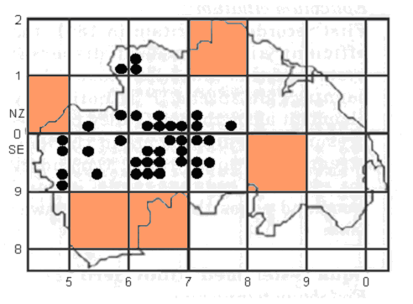
NorthSea
National Park Boundary
Tetrad (2x2km) where ring ouzels have been recorded as holding territory between 1999 and 2008.
10km square where there has been no confirmation of ring ouzels breeding since the 1968-1972 BBA survey.
National Park Boundary
Sites where Fenno-Scandia spring passage migrants were recorded in 2008.
Figure 3: Tetrads holding a ring ouzel territory in the North York Moors
between 1999-2008 and the tetrads where spring passage migrants
were recorded.

Passage Migrants

The sighting of a single ring ouzel on the coast at Scalby Lodge (TA026916) on the 18th April and two further north at Ravenscar (NZ985015) on 24th were most likely Fenno-Scandia birds on passage. A group of eight seen on the east side of Rosedale between Reeking Gill (NZ692006) and East Mines (SE705989) on 20th April stayed in the area for 3 days departing on the 23rd. Six seen feeding below the Lion Inn (NZ682000) at the north end of Rosedale on 21st April were possibly from the same group. These birds were thought to be passage migrants, ‘blown’ across from the coast in the strong easterly winds that persisted over that period, as the majority of resident birds by then had established territories and were singing.

Rosedale Nests

Hob Crag
Two nests were attempted in 2008 but both were predated; the first at the chick stage and the second at the egg stage. The first nest was constructed on the same rock ledge as in 2003 and 2004. The second nest was in the central part of the quarry about two metres above the quarry floor. All six nests located over the years at this site have been predated. After the second failure the adults were not seen again.

Dalehead north
As in previous years the steep heather bank on the west side of Rosedale at Dalehead attracted a pair of ring ouzels. The 2008 site occupied a position some 300 metres north of the previous year’s site. The nest was found on 5th June and contained four eggs. On the 9th June one hatchling, newly hatched that day, and three eggs were noted. Ten days later on the 19th June the nest was found empty apart from one unhatched egg. The reason for this outcome is not clear but the most likely explanation is that it was predated at the pulli stage with the one
remaining egg being infertile and of no interest to the predator. The lateness of this nest suggest it was a replacement nest for a failed first attempt.

Round Hill south
The male at this location was one of the early arrivals in the dale and was first seen on 30th March feeding in the meadow below the crag. He was joined by a female on 14th April where both were seen feeding together. The resident male was seen defending his territory and seeing-off an unattached male on 1st May. On 4th May the nest was located in exactly the same place as in 2007 and appeared to be last year’s nest refurbished. Four eggs had been laid. A second brood appeared to have been attempted with the female’s behaviour on the 24th June suggesting she had a nest near to the first nest site. Despite lengthy periods of observation the birds proved too cunning and as in 2007 the second nest was never found.

Reeking Gill
The nest at Reeking Gill was located on 12th May containing five eggs. By 2nd June all five young had fledged and both adults were seen on the 5th June 300 metres south of the gill below Nab Scar with two juveniles. During this time the male was heard singing and an audio recording confirmed that this was the same male as recorded in the gill three weeks earlier. A second nest does not appear to have been attempted.

Sheriff’s Pit
A male and female were seen prospecting for a nest site in the pit on 4th May. Despite several attempts to locate the nest over the following days and weeks, it was not until the 29th May that the nest was seen on the north-west side of the shaft with four hatchlings. This site demonstrated how difficult it can be to locate a nest and for the adult birds to remain well hidden during the incubation stage. There were no further sightings of this pair after the young had fledged and a second nest does not appear to have been attempted.

Sturdy Bank
After an absence of five years a pair successfully raised two broods at Sturdy Bank. The first located on the 5th May was about half way up the east side of the gill, while the second, found on the 16th June, was close to the bottom of the gill about 30 metres below the first nest. Both nests had four eggs and all hatched. The first nest fledged four young, the second, three. A feature of both nests was their exposed position where it was possible to see into the nests from the opposite side of the gill. The first nest was at ground level and the young, just a day or two before they left the nest, were seen making short forays within a metre of the nest before returning to the ‘safety’ of the nest. The first-egg of the second nest was laid 13 days after the young left the first nest. A unique sequence of photographs were taken of the second nest showing the various stages of hatchling development from day 0 to day 10 (Annex 8).

As in previous years all nests and territories recorded were located above the 250 metres contour (the tree line on the North York Moors). Those in Rosedale were found between 280 metres and 380 metres (Annex 4, Fig. 2).

All but one of the ring ouzel feeding areas were grazed during the study period by sheep, the exception being Round Hill south where the large areas of unimproved meadow preferred by the ring ouzels were grazed by rabbits. As observed in previous years there is no evidence of either over or under grazing in the area covered by this study. The Rosedale moorland is keepered.

Late Summer & Early Autumn Activity

As in 2007 a late season visit was made to Rosedale specifically to locate ring ouzels prior to migration. The visits concentrated mainly on the west side of the dale around Blakey Swang where there were known to be a number of stands of mature rowan trees.

The first visit on 28th August found nothing, though the rowan trees were laden with berries.

The next visit on 11th September located seven ring ouzels; 3 males, possibly 2 first winter young and 2 females. At one point all seven were seen perched on an overhead power line facing the same way. All were seen foraging in an adjoining meadow and appeared to be feeding on invertebrates. Non were seen feeding on berries. Two more ring ouzels were seen in a rowan tree about a kilometre further north, these were thought to be additional to the seven seen earlier. A flock of over 40 mistle thrushes and 10 or so starlings were also seen in the area.

A further visit a week later on 18th September located a pair and one juvenile atop a rowan tree feeding on berries. Later the male was seen pursuing a kestrel while sounding the alarm call.

On the 25th September a male and female were seen feeding on berries in the same tree as on the 18th. Four mistle thrushes were seen in the area.

The final visit on 2nd October found nothing other than a small flock of mistle thrushes.

Coastal sightings were reported on 9th November at Cloughton.

Rowan berries are an essential food source for several species of birds in the Autumn; with the ring ouzel switching to berries ahead of migration. It is of concern that there is no sign of rowan regeneration in Rosedale, due chiefly to browsing by sheep and dear. A planting scheme should be considered to ensure the continuation of this important source of food.

Unattached Males

During the season there were several sightings of individual males that appeared to be unattached.

A skirmish between two males was seen at Hob Crag on 15th April. By then the resident male had paired and the second male appeared to be attempting to attract the female away from him. Several attempts were made by the lone male to land next to the female, each time the resident bird attacked the interloper and chased it away closely followed by the female.

On the 28th April a male was seen atop a tree at Sledge Shoe Bents (SE690976) singing a mixture of simple and complex song. The reaction of the bird to the tape lure being played was unusual in that it continued to sing in a more purposeful manner while looking fixedly in the direction of the lure some 50 metres away. The response seemed to suggest that the bird was looking for a partner and that it saw the lure as competition and was not going to be outdone.

A short distance away another male was seen atop a tree singing a varied mixture of simple and complex song. At one stage both males were heard singing together giving the impression that they were trying to outdo each other. Again the response to the lure was the same, if anything making the bird more vocal.

Two males were seen feeding in the meadow below the crag at Round Hill south on 1st May. One male, assumed to be the resident bird, was seen to hustle the other male until it eventually left the area. The resident male then flew to the top of the crag near to the nest site and started singing.

Sound Recordings, Sonograms and their Analysis

A start was made in 2008 on creating a database of ring ouzel songs. The aim was to use the sonogram of each bird’s song to assist in tracking individual male ring ouzels in the North York Moors as an alternative to the established method of ringing.

The sound recording equipment was purchased in late May with a generous grant from the National Park Authority. The equipment consisted of an Edirol R09 HR compact sound recorder and a AUDIO ATR55 TECHNICA shotgun microphone. Raven Lite 1 sound analysis software from Cornell Lab of Ornithology was used to produce the sonograms and ViSta visual statistics software to analyse the recordings and create an ‘audiotag’.

The intention was to spend the 2008 season getting familiar with the setup and finding answers to questions such as: how close to the bird did you need to be?; was a hand held microphone adequate or would it be necessary to use more sophisticated equipment?; would a weak recording still be usable? These and other questions it was hoped would be answered in 2008, helped by the few remaining weeks that were left in the season when the males were still singing.

The songs of four male ring ouzels were recorded and analysed in 2008: Reeking Gill; Dalehead north; Round Hill; and, Round Hill south (a recording of a male below Nab Scar was later identified as the Reeking Gill bird - see below). A selection of sonograms are shown at Annex 7 including a recording made in 2003 at Rosedale, Blakey Bank, by the late David Stemple.

The use of sonograms to identify individual birds is illustrated in Figure 4 and 5 below. A singing male was recorded in the gill at Reeking Gill on 15th May (Fig. 4). Three weeks later on 5th June a male was heard singing some 300 metres south of Reeking Gill (Fig. 5). Because of the close proximity to two other known territories, Nab Scar and Sturdy Bank, it was not clear at the time if this was the male from Reeking Gill or one of these other territories. Analysis of the two sonograms showed there was a good match and that the bird was most likely the one that nested in Reeking Gill (see Fig. 6).

tend
tmax
tbeg
tmin
dur2
dur1
dur3
fmin
fmax
tend
tmax
tbeg
tmin
dur2
dur1
dur3
fmin
fmax
Figure 5: Sonogram of a single note of a male singing in the meadow below Rosedale, Nab Scar, 5 June 2008.

Figure 4: Sonogram of a single note of a male singing in the gill at Rosedale, Reeking Gill, 15 May 2008.

Measured parameters in the ring ouzel simple song used in identifying individual birds are shown in the single note sonograms above (Fig. 4 & 5). Points of measurement for: beginning time (tbeg), end time (tend), maxima time (tmax) and minima time (tmin), and maxima frequency (fmax) and minima frequency (fmin) of fundamental frequency are shown. Measurements of temporal parameters: durations of first and second sections of call (dur1 & dur2), and durations between the maxima time and end time (dur3) are also illustrated.
Table 7. Mean values of parameters dur1, dur2 and dur3 measured from sonograms of sound recordings taken at five locations in Rosedale in 2008.

Location | dur1  milliseconds | dur2  milliseconds | dur3  milliseconds | Sample Size
Dalehead north | 61 | 141 | 179 | 3
Nab Scar (below) | 75 | 137 | 180 | 10
Reeking Gill | 74 | 137 | 180 | 10
Round Hill | 85 | 63 | 125 | 6
Round Hill south | 65 | 137 | 174 | 10
Note:
- Sample size is the number of notes of the song used to determine the mean value of the three temporal parameters dur1, dur2 & dur3.
- Low sample of Dalehead north recording is due to weak sound recording.

Reeking Gill
Nab Scar (below)
Dalehead north
Round Hill south
Round Hill ‘bubble’ is off the scale.
Figure 6: Bubble chart of temporal parameters dur1, dur2 & dur3 (circle width) taken from Table 7. Overlap of Reeking Gill and Nab Scar bubbles suggests they are most likely the same bird.

The measurement techniques will be refined as further work is done on defining the most suitable set of parameters for analysing and identifying individual birds.

5. ACKNOWLEDGEMENTS
The authors wish to thank a local resident for her invaluable assistance and the support of estate owner George Winn-Darley, head keeper George Thompson and Northdale beat keeper, Peter Richardson. Also to Tom Denney and Jim Pewtress for reports of ring ouzel sightings during the 2008 season. Our thanks also to Rona Charles of the North York Moors National Park Authority for help in securing funding to purchase sound recording equipment.

6. REFERENCES

Appleyard, I. (1994) Ring Ouzels of the Yorkshire Dales.

Burfield, I.J. (2002) The breeding ecology and conservation of the ring ouzel Turdus torquatus in Britain. University of Cambridge.

Gibbons, D.W., Reid J. B. and Chapman, R. A. (1993) The new atlas of breeding birds in Britain and Ireland: 1988-1991. T. & A.D. Poyser Ltd, London.

Mayfield, H.F. (1961) Nesting success calculated from exposure. Wilson Bulletin 73:255-261

Mayfield, H.F. (1975) Suggestions for calculating nest success. Wilson Bulletin 87:456-466

ANNEX 1 - Nest sites and territories located in 2008

02  01  67  68 | 69  Dalehead north | 70 | 71 | 72 | 73 |  | N  74 | 75
00  NZ |  | Reeking Gill  Reeking Gill west
99  SE | Blakey Swang | 250 | 300  350  Sturdy Bank | West Gill | North Gill |  |  | 350
250  98 | 300  350 | Matty Carr Hill | East Mines |  |  |  |  | 300
97 |  | Round Hill
96 |  | Round Hill south  Sheriff’s Pit | Thorgill
95 |  |  |  | Hobb Crag | Rosedale Abbey |  |  | 250
94 |  |  | 300
93 |  | 250
92 |  |  |  | Spindle Thorn
Diagram 1: Ring ouzel nest sites and territories located in 2008 in the Rosedale area of the North York Moors.

Territory:
Nest Site:
Track:
Contour:
250
Road:
Narrow Road:
KEY

ANNEX 2 - Annual Breeding Results

Table 1: Annual breeding results at ring ouzel nest sites in the Rosedale and other areas of the
North York Moors. Data from 2000 to 2008

Year | Site | Grid Ref. | Eggs | Hatched | Fledged | Comments
2000 | Spaunton | SE71479347 | 4 | 4 | 4 | 1st brood. 4 pulli ringed.
2002 | Bank Top | ? | ? | ? | ? | First attempt not found.
2002 | Bank Top | SE72049483 | + | 4 | 4 | Likely to be 2nd brood.
2003 | Ouzegill Bdg. | SE63709450 | 4 | 4 | 4 | 1st brood. 4 pulli ringed.
2003 | Round Hill | SE69279710 | 4 | 4 | 4 | 1st brood
2003 | Thorgill Head | SE69999559 | 4 | 3 | 0 | 1st brood. Nest disturbed, chicks abandoned.
2003 | Thorgill Bank | SE70729582 | 4 | 3 | 3 | 1st brood. 3 pulli ringed.
2003 | Thorgill Bank | SE70729582 | 2 | 1 | ? | 2nd brood. Likely to have failed at pulli stage.
2003 | Loskey Ridge | SE71489347 | 4 | + | 0 | 1st nest. Predated at pulli stage.
2003 | Hob Crag | SE71459538 | 4 | 0 | 0 | Likely to be 1st nest. Predated at egg stage.
2004 | Hob Crag | SE71459538 | 4 | 4 | 0 | Predated at pulli stage. Refurbished 2003 nest.
2004 | Matty Carr | SE68809833 | 4 | 4 | 4 | Likely to be 1st brood.
2004 | Dale Hd East | ? | ? | ? | ? | First attempt not found
2004 | Dale Hd East | NZ68560086 | 4 | 4 | 4 | Likely to be 2nd brood.
2004 | Ouzegill Bdg. | SE63909470 | 2 | 1 | ? | 1st brood. 1 egg vanished. 1 pulli ringed.
2005 | Sheriff’s Pit 1 | SE69659631 | + | 1 | 0 | 1st nest. Nest abandoned; reason unknown.
2005 | Sheriff’s Pit 1 | SE69659631 | + | 0 | 0 | 2nd attempt. Predated at egg stage.
2005 | Sheriff’s Pit 1 | SE69659631 | + | 3 | 2 | 3rd nest.
2005 | Matty Carr | SE68809835 | 4 | 4 | 4 | Thought to be 1st brood.
2005 | Lion Inn | ? | ? | ? | ? | First attempt not found
2005 | Lion Inn | SE68249954 | + | 4 | 4 | Likely to be 2nd brood.
2005 | Dale Hd West | NZ67960082 | + | + | 3 | 3 fledglings seen near nest.
2006 | Sheriff’s Pit 1 | SE69659631 | 4 | 0 | 0 | Nest on NW side of pit shaft washed out by heavy rain in mid May.
2006 | Sheriff’s Pit 2 | SE69779609 | 5 | 5 | 5 | Second attempt 185m Sth. of pit shaft.
2006 | Dale Hd West | ? | ? | ? | ? | First attempt not found
2006 | Dale Hd West | NZ67930081 | 4 | ? | ? | Likely to be 2nd brood.
2007 | Hob Crag | SE71459538 | 3 | 0 | 0 | 1st nest. Predated at egg stage.
2007 | Round Hill Sth | SE69819663 | 4 | 4 | 4 | 1st nest.
2007 | Dale Hd West | NZ67940079 | 4 | 4 | 4 | 1st nest.
2007 | Reeking Gill | NZ68920066 | 4 | 4 | 4 | 1st nest.
2008 | Sturdy Bank 1 | SE69899991 | 4 | 4 | 4 | 1st nest.
2008 | Sturdy Bank 2 | SE69869990 | 4 | 4 | 3 | 2nd nest.
2008 | Round Hill Sth | SE69819664 | 4 | 4 | 4 | 1st nest. Used refurbished 2007 nest.
2008 | Reeking Gill | NZ69140056 | 5 | 5 | 5 | 1st nest.
2008 | Northdale, W. Gill | SE71799957 | + | + | 3 | 1st nest.
2008 | Hobb Crag 1 | SE71449539 | 4 | 4 | 0 | 1st attempt. Predated at pulli stage. Used same nest site as in 2003/4.
2008 | Hobb Crag 2 | SE71399545 | 3 | 0 | 0 | 2nd attempt. Predated at egg stage.
2008 | Sheriff’s Pit | SE69719626 | 4 | 4 | 4 | 1st brood.
2008 | Dalehead Nth. | ? | ? | ? | ? | First attempt not found
2008 | Dalehead Nth. | NZ67950102 | 4 | 1 | 0 | Likely to be 2nd attempt. Appeared to have failed after 1st hatchling. 1 abandoned egg left in nest.
? = No data. + = Exact value unknown.

ANNEX 3 - Table showing Aspect & Elevation of Nest Sites

Table 1: Aspect and elevation of 35 ring ouzel nest sites in the Rosedale area of the
North York Moors. Data from 1999 to 2008.

Year | Location | Grid Reference | Aspect | Elevation
1999 | Rosedale - Sheriff’s Pit | SE 6973 9627 | NNW | 331m
1999 | Blakey Crossing | SE 6830 9900 | SSW | 370m
2000 | Spaunton Moor - Penwash | SE 7147 9347 | SSW | 240m
2002 | Rosedale - Bank Top | SE 7204 9483 | NNW | 310m
2003 | Rosedale - Round Hill | SE 6927 9710 | N | 336m
2003 | Rosedale - Hobb Crag | SE 7145 9538 | NNE | 313m
2003 | Rosedale - Thorgill Head | SE 6999 9559 | NNE | 330m
2003 | Rosedale - Thorgill Bank | SE 7073 9580 | NE | 308m
2003 | Spaunton Moor - Penwash | SE 7148 9347 | NE | 249m
2003 | Rosedale - Thorgill Bank | SE 7072 9582 | ENE | 309m
2004 | Rosedale - Matty Carr Hill | SE 6880 9833 | E | 358m
2004 | Rosedale - Sheriff’s Pit | SE 6971 9626 | SSE | 331m
2004 | Rosedale - DaleHead (east) | NZ 6856 0086 | SW | 330m
2005 | Rosedale - Sheriff’s Pit | SE 6971 9626 | NE | 339m
2005 | Rosedale - Blakey Lion | SE 6824 9954 | ENE | 362m
2005 | Rosedale - Dale Head (west) | NZ 6796 0082 | E | 349m
2005 | Rosedale - Sheriff’s Pit | SE 6971 9626 | ESE | 333m
2005 | Rosedale - Matty Carr Hill | SE 6880 9835 | SE | 331m
2005 | Rosedale - Sheriff’s Pit | SE 6971 9626 | SW | 331m
2006 | Rosedale - Sheriff’s Pit (south) | SE 6979 9610 | N | 339m
2006 | Rosedale - Dale Head (west) | NZ 6793 0080 | E | 362m
2006 | Rosedale - Sheriff’s Pit | SE 6971 9626 | ESE | 333m
2007 | Rosedale - Reeking Gill (west) | NZ 6892 0066 | N | 321m
2007 | Rosedale - Round Hill (south) | SE 6981 9664 | NNE | 297m
2007 | Rosedale - Hob Crag | SE 7138 9546 | E | 342m
2007 | Rosedale - Dale Head (west) | NZ 6794 0079 | S | 357m
2008 | Rosedale - Round Hill (south) | SE 6981 9664 | NNE | 297m
2008 | Rosedale - Hob Crag 1 | SE 7144 9539 | NNE | 310m
2008 | Rosedale - Hob Crag 2 | SE 7139 9545 | NE | 313m
2008 | North Dale - West Gill | SE 7179 9957 | NE | 308m
2008 | Rosedale - Dalehead (north) | NZ 6795 0102 | NE | 353m
2008 | Rosedale - Sheriff’s Pit | SE 6971 9626 | SSE | 331m
2008 | Rosedale - Sturdy Bank 1 | SE 6989 9991 | W | 307m
2008 | Rosedale - Sturdy Bank 2 | SE 6986 9990 | SSW | 281m
2008 | Rosedale - Reeking Gill | NZ 6914 0056 | W | 322m

ANNEX 4 - Nest Aspect & Elevation of Rosedale Nests

Number of nests facing:-
N
S
WNW
WSW
Figure 1: Number of nests facing principal compass points in the Rosedale area of the North York Moors. Data from 1999-2008, n=35 nests.

Figure 2: Elevation above mean sea level of nests in Rosedale, North York Moors. Data from 1999-2008, n=31 nests.
Tree line
Lowest
point
Highest point

ANNEX 5/1 - Fine-Scale Habitat Survey of Nesting Area

Note:
Other includes: Trees - silver birch Betula pendula, rowan Sorbus aucuparia; Plants - sheep's sorrel Rumex acetosella, heath bedstraw Galium saxatile.

ANNEX 5/2 - Fine-Scale Habitat Survey of Nest Site

Note:
Other includes: Trees - silver birch Betula pendula, rowan Sorbus aucuparia; Plants - sheep's sorrel Rumex acetosella, heath bedstraw Galium saxatile.

ANNEX 6/1 - Daily Maximum & Minimum Temperature

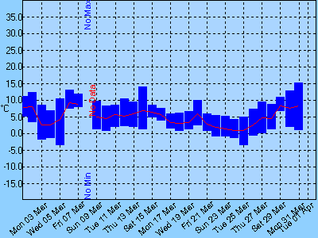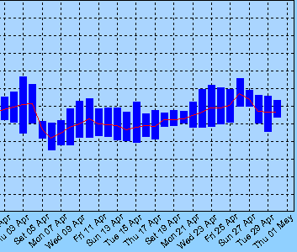
March - April

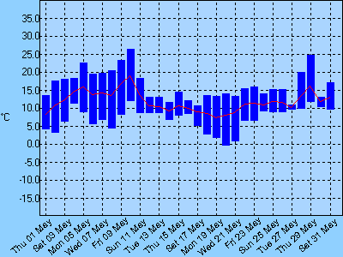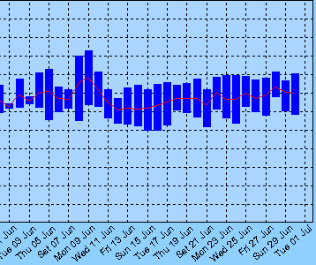
May - June

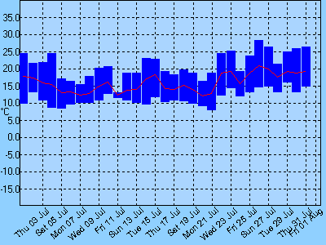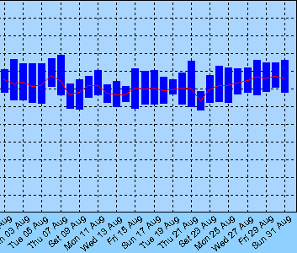
July - August

Daily maximum and minimum temperature recorded at Scaling Dam (NZ741126) between March and August 2008.

ANNEX 6/2 - Daily Rainfall

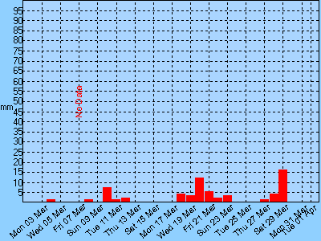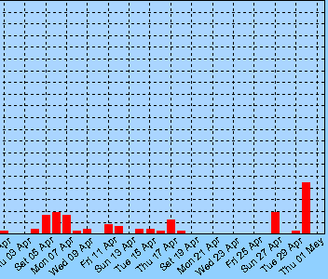
March - April

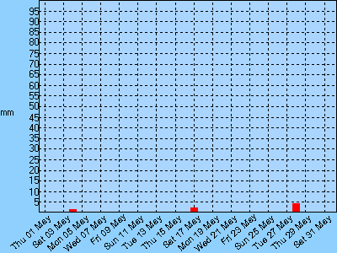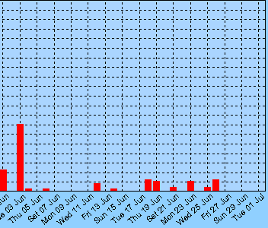
May - June

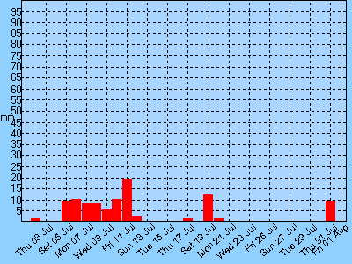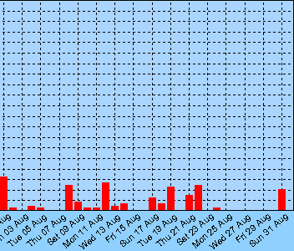
July - August

Daily rainfall recorded at Scaling Dam (NZ741126) between March and August 2008

ANNEX 7 - Sonograms

Diagram 1: Male singing at Rosedale, Dalehead north, 5 May 2008 at 1042hrs

Diagram 2: Male singing at Rosedale, Hob Crag, 22 May 2008 at 1717hrs.
(weak sound recording)

Diagram 3: Male singing at Rosedale, Round Hill, 29 May 2008 at 1503hrs.

Diagram 4: Male singing at Rosedale,
Blakey Bank, 23 April 2003 at 0720hrs.
Showing modulation of basic simple song at
83 Hertz giving raspy buzzing sound to call.
(recording by D.Stemple)

ANNEX 8 - Photographs of Hatchling Development

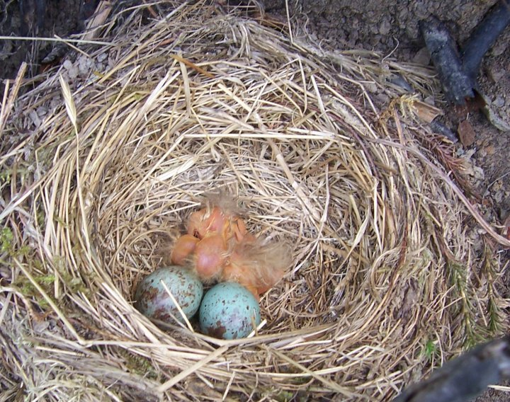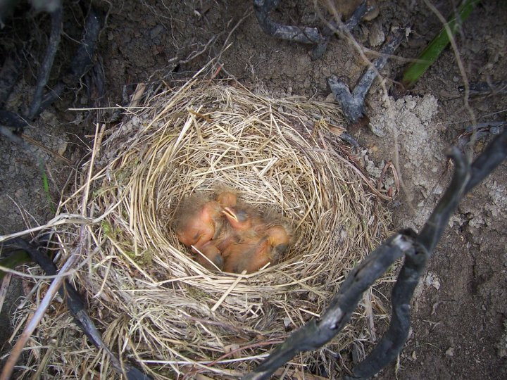
Two newly hatched chicks just a few hours old - the 2 remaining eggs hatched 24 hours later.
First chicks now 1 day old with the 2 remaining eggs newly hatched and just a few hours old.

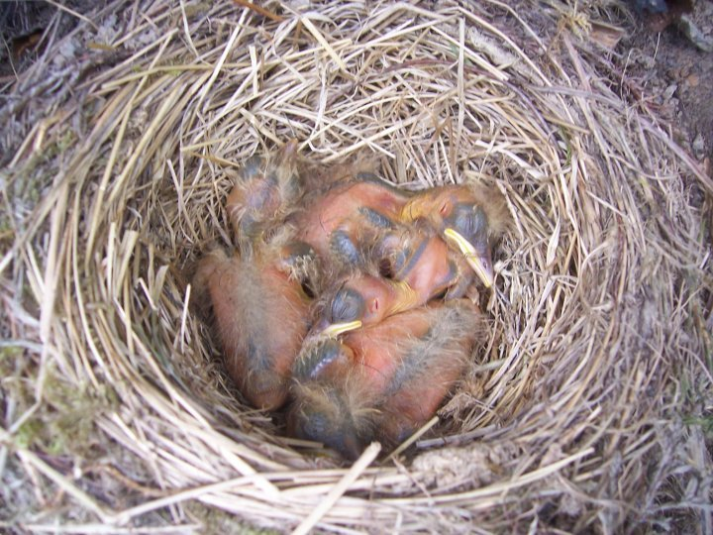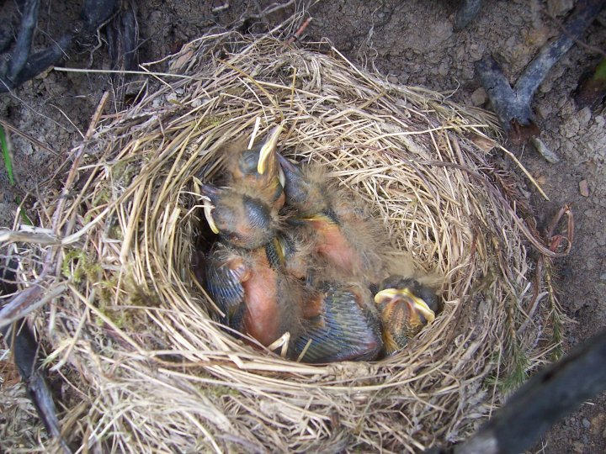
Chicks 2 and 3 days old.
Chicks 4 and 5 days old.

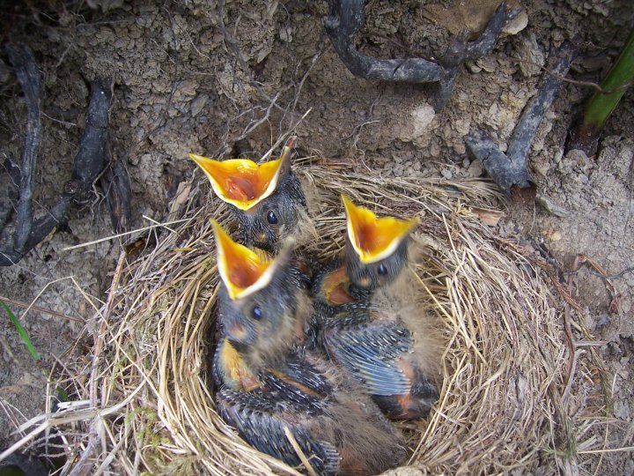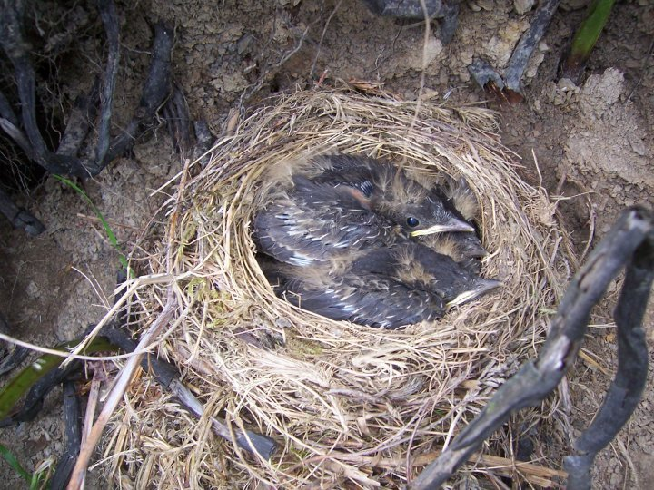
Chicks 6 and 7 days old.

Chicks 9 and 10 days old.

Photographs taken at Rosedale, Sturdy Bank, between 25th June and 5th July 2008.

